How WiFi Works
Introduction to How WiFi Works
If you've been in an airport, coffee shop, library or hotel recently, chances are you've been right in the middle of a wireless network. Many people also use wireless networking, also called WiFi or 802.11 networking, to connect their computers at home, and an increasing number of cities use the technology to provide free or low-cost Internet access to residents. In the near future, wireless networking may become so widespread that you can access the Internet just about anywhere at any time, without using wires.

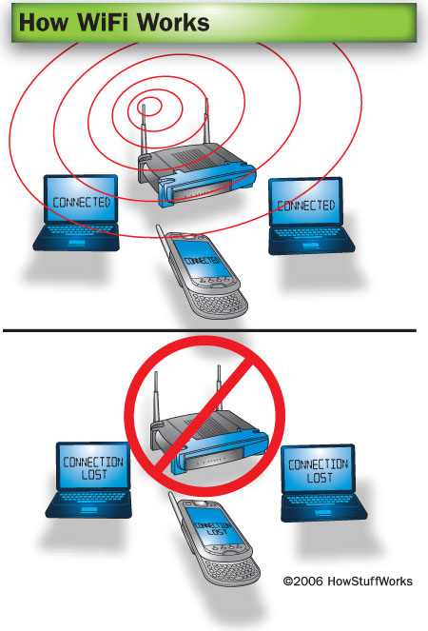
One wireless router can allow multiple devices to connect to the Internet.
WiFi has a lot of advantages. Wireless networks are easy to set up and inexpensive. They're also unobtrusive -- unless you're on the lookout for a place to use your laptop, you may not even notice when you're in a hotspot. In this article, we'll look at the technology that allows information to travel over the air. We'll also review what it takes to create a wireless network in your home.
First, let's go over a few WiFi basics.
What Is WiFi?
A wireless network uses radio waves, just like cell phones, televisions and radios do. In fact, communication across a wireless network is a lot like two-way radio communication. Here's what happens:
- A computer's wireless adapter translates data into a radio signal and transmits it using an antenna.
- A wireless router receives the signal and decodes it. It sends the information to the Internet using a physical, wired Ethernet connection.
The process also works in reverse, with the router receiving information from the Internet, translating it into a radio signal and sending it to the computer's wireless adapter.
The radios used for WiFi communication are very similar to the radios used for walkie-talkies, cell phones and other devices. They can transmit and receive radio waves, and they can convert 1s and 0s into radio waves and convert the radio waves back into 1s and 0s. But WiFi radios have a few notable differences from other radios:
- They transmit at frequencies of 2.4 GHz or 5GHz. This frequency is considerably higher than the frequencies used for cell phones, walkie-talkies and televisions. The higher frequency allows the signal to carry more data.
- They use 802.11 networking standards, which come in several flavors:
  - 802.11a transmits at 5GHz and can move up to 54 megabits of data per second. It also uses orthogonal frequency-division multiplexing (OFDM), a more efficient coding technique that splits that radio signal into several sub-signals before they reach a receiver. This greatly reduces interference.
  - 802.11b is the slowest and least expensive standard. For a while, its cost made it popular, but now it's becoming less common as faster standards become less expensive. 802.11b transmits in the 2.4 GHz frequency band of the radio spectrum. It can handle up to 11 megabits of data per second, and it uses complimentary code keying (CCK) coding.
  - 802.11g transmits at 2.4 GHz like 802.11b, but it's a lot faster -- it can handle up to 54 megabits of data per second. 802.11g is faster because it uses the same OFDM coding as 802.11a.
  - 802.11n is the newest standard that is widely available. This standard significantly improves speed and range. For instance, although 802.11g theoretically moves 54 megabits of data per second, it only achieves real-world speeds of about 24 megabits of data per second because of network congestion. 802.11n, however, reportedly can achieve speeds as high as 140 megabits per second.
- WiFi radios can transmit on any of three frequency bands. Or, they can "frequency hop" rapidly between the different bands. Frequency hopping helps reduce interference and lets multiple devices use the same wireless connection simultaneously.
Other Wireless Networking Standards
Another wireless standard with a slightly different number, 802.15, is used for Wireless Personal Area Networks (WPANs). It covers a very short range and is used for Bluetooth technology.
WiMax, also known as 802.16, looks to combine the benefits of broadband and wireless. WiMax will provide high-speed wireless Internet over very long distances and will most likely provide access to large areas such as cities. WiMax technology will be available in most American cities in 2008.
As long as they all have wireless adapters, several devices can use one router to connect to the Internet. This connection is convenient and virtually invisible, and it's fairly reliable. If the router fails or if too many people try to use high-bandwidth applications at the same time, however, users can experience interference or lose their connections.
Next, we'll look at how to connect to the Internet from a WiFi hotspot.
What's in a Name?
You may be wondering why people refer to WiFi as 802.11 networking. The 802.11 designation comes from the Institute of Electrical and Electronics Engineers (IEEE). The IEEE sets standards for a range of technological protocols, and it uses a numbering system to classify these standards.
WiFi Hotspots
If you want to take advantage of public WiFi hotspots or start a wireless network in your home, the first thing you'll need to do is make sure your computer has the right wireless gear. Most new laptops and many new desktop computers come with built-in wireless transmitters. If your laptop doesn't, you can buy a wireless adapter that plugs into the PC card slot or USB port. Desktop computers can use USB adapters, or you can buy an adapter that plugs into the PCI slot inside the computer's case. Many of these adapters can use more than one 802.11 standard.
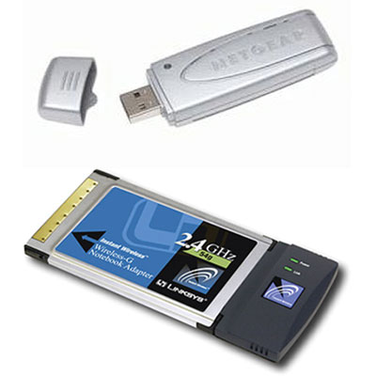
USB wireless adapter and PC wireless card photos courtesy Consumer Guide Products
Wireless adapters can plug into a computer's PC card slot or USB port.
Once you've installed your wireless adapter and the drivers that allow it to operate, your computer should be able to automatically discover existing networks. This means that when you turn your computer on in a WiFi hotspot, the computer will inform you that the network exists and ask whether you want to connect to it. If you have an older computer, you may need to use a software program to detect and connect to a wireless network.
Being able to connect to the Internet in public hotspots is extremely convenient. Wireless home networks are convenient as well. They allow you to easily connect multiple computers and to move them from place to place without disconnecting and reconnecting wires. In the next section, we'll look at how to create a wireless network in your home.
Building a Wireless Network
Quiz Corner
How much you know about WiFi and what it does? Test your knowledge with our WiFi Quiz!
If you already have several computers networked in your home, you can create a wireless network with a wireless access point. If you have several computers that are not networked, or if you want to replace your Ethernet network, you'll need a wireless router. This is a single unit that contains:
- A port to connect to your cable or DSL modem
- A router
- An Ethernet hub
- A firewall
- A wireless access point
A wireless router allows you to use wireless signals or Ethernet cables to connect your computers to one another, to a printer and to the Internet. Most routers provide coverage for about 100 feet (30.5 meters) in all directions, although walls and doors can block the signal. If your home is very large, you can buy inexpensive range extenders or repeaters to increase your router's range.
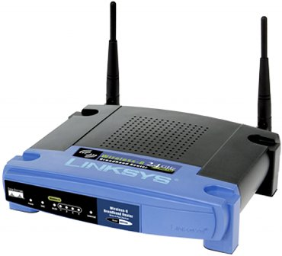
Photo courtesy Consumer Guide Products
A wireless router uses an antenna to send signals to wireless devices and a wire to send signals to the Internet.
As with wireless adapters, many routers can use more than one 802.11 standard. 802.11b routers are slightly less expensive, but because the standard is older, they're slower than 802.11a, 802.11g and 802.11n routers. Most people select the 802.11g option for its speed and reliability.
Once you plug in your router, it should start working at its default settings. Most routers let you use a Web interface to change your settings. You can select:
- The name of the network, known as its service set identifier (SSID) -- The default setting is usually the manufacturer's name.
- The channel that the router uses -- Most routers use channel 6 by default. If you live in an apartment and your neighbors are also using channel 6, you may experience interference. Switching to a different channel should eliminate the problem.
- Your router's security options -- Many routers use a standard, publicly available sign-on, so it's a good idea to set your own username and password.
Security is an important part of a home wireless network, as well as public WiFi hotspots. If you set your router to create an open hotspot, anyone who has a wireless card will be able to use your signal. Most people would rather keep strangers out of their network, though. Doing so requires you to take a few security precautions.
To keep your network private, you can use one of the following methods:
- Wired Equivalency Privacy (WEP) uses 64-bit or 128-bit encryption. 128-bit encryption is the more secure option. Anyone who wants to use a WEP-enabled network has to know the WEP key, which is usually a numerical password.
- WiFi Protected Access (WPA) is a step up from WEP and is now part of the 802.11i wireless network security protocol. It uses temporal key integrity protocol encryption. As with WEP, WPA security involves signing on with a password. Most public hotspots are either open or use WPA or 128-bit WEP technology.
- Media Access Control (MAC) address filtering is a little different from WEP or WPA. It doesn't use a password to authenticate users -- it uses a computer's physical hardware. Each computer has its own unique MAC address. MAC address filtering allows only machines with specific MAC addresses to access the network. You must specify which addresses are allowed when you set up your router. This method is very secure, but if you buy a new computer or if visitors to your home want to use your network, you'll need to add the new machines' MAC addresses to the list of approved addresses.
Wireless networks are easy and inexpensive to set up, and most routers' Web interfaces are virtually self-explanatory. For more information on setting up and using a wireless network, check out the links on the next page.

